University of Central Missouri
Department of Computer Science & Cybersecurity

CS5710 Machine Learning
Fall 2025

Home Assignment 4.

Student name:
SHANMUKHA SHIVA KESAVA VARMA INDUKURI-700766407

Submission Requirements:
- Once finished your assignment push your source code to your repo (GitHub) and explain the work through the ReadMe file properly. Make sure you add your student info in the ReadMe file.
- Comment your code appropriately IMPORTANT.
- Any submission after provided deadline is considered as a late submission.

Part A: Calculation
Q1. Find the cluster using the Average and MIN technique. Use Euclidean distance to build the complete distance matrix, updated the distance matrix to the final step and draw the dendrogram for each.
 | X | Y
P1 | 0.4 | 0.5
P2 | 0.2 | 0.3
P3 | 0.1 | 0.08
P4 | 0.21 | 0.12
P5 | 0.6 | 0.16
P6 | 0.33 | 0.28
P7 | 0.11 | 0.15
Answer:
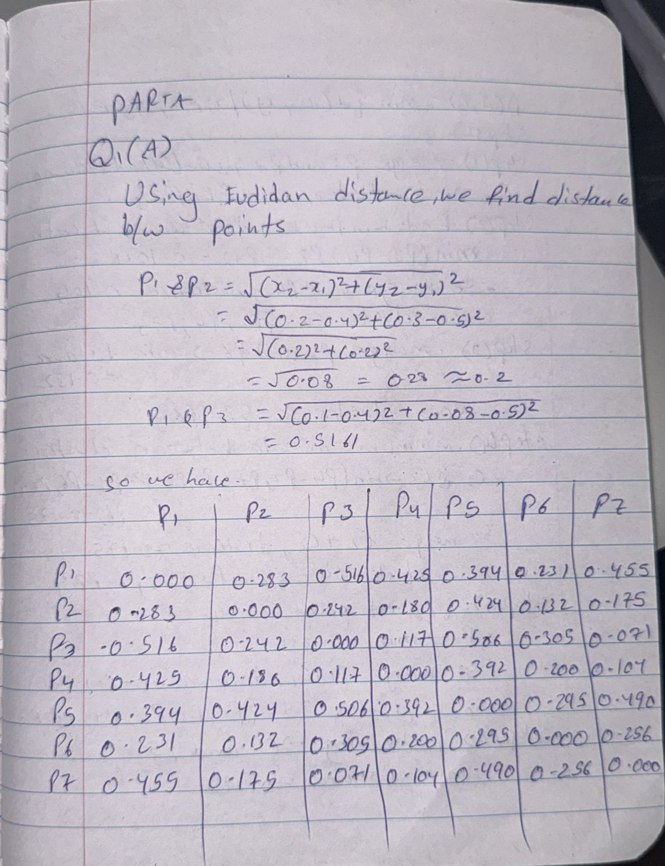
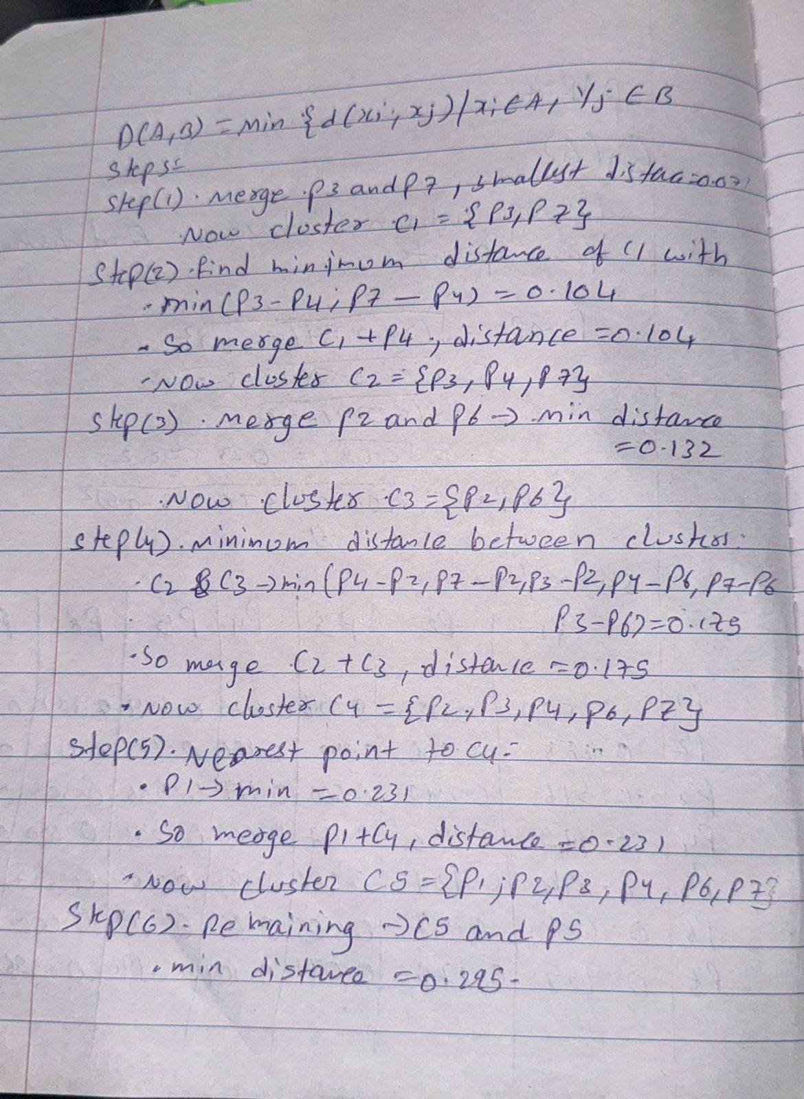
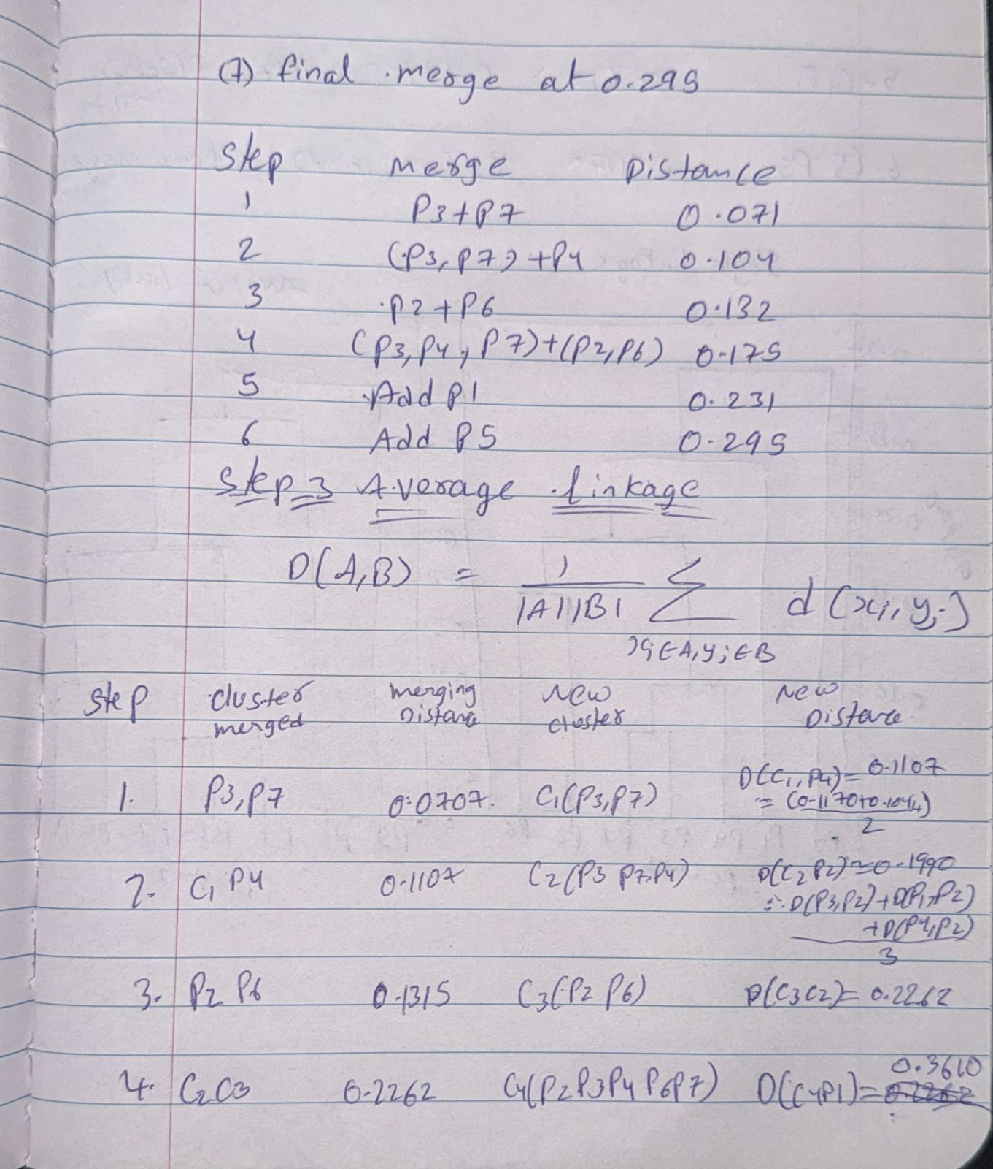
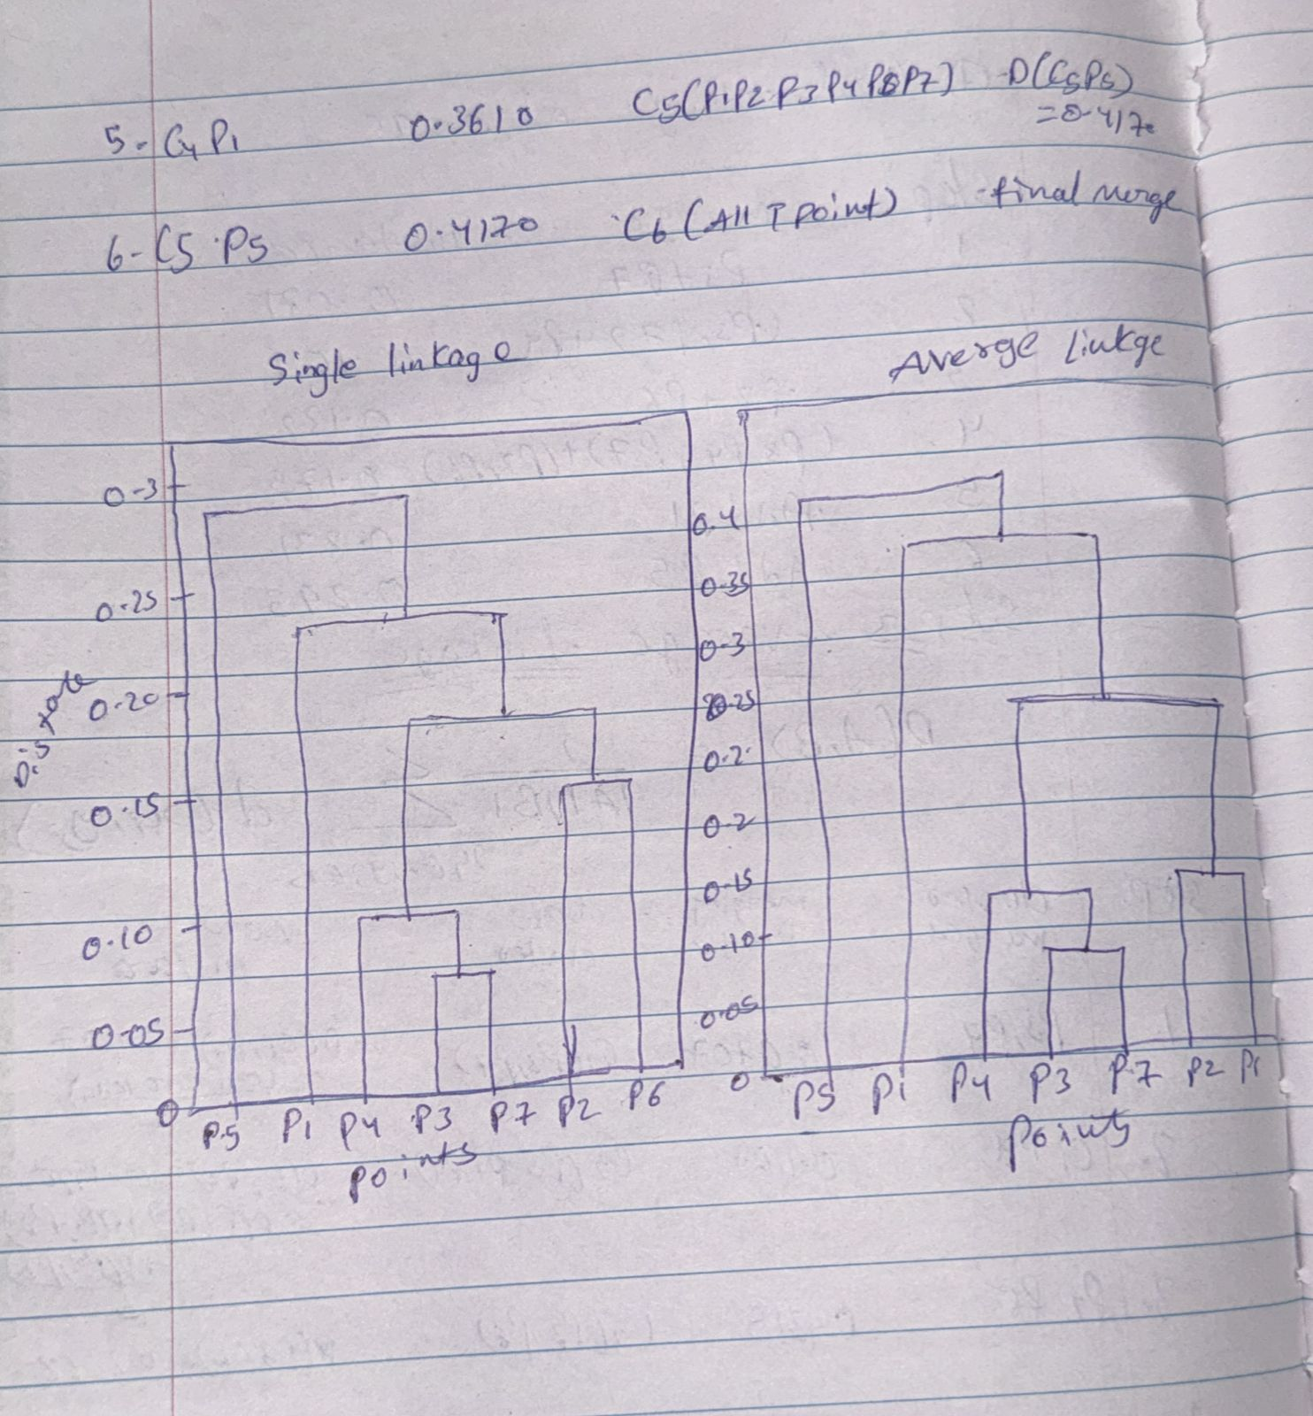

Q2. We have the following 2D data points:
Points: (2,1), (3,1), (3, 3), (4, 1), (5, 1), (6,7), (1,3), (2,5) for K =3:
Centroid1: (2,1)
Centroid 2: (4, 1)
Centroid 3: (5, 1)

Euclidean Distance:

Answer :

Euclidean Distance:
$$d=\sqrt{(x_{i}-x_{j})^{2}+(y_{i}-y_{j})^{2}}$$

Step 1: Distance Calculations
At Centroid 1 (2,1)
Point | Calculation | Distance
P1(2,1) | √((2-2)²+(1-1)²) | 0.00
P2(3,1) | √((3-2)²+(1-1)²) | 1.00
P3(3,3) | √((3-2)²+(3-1)²) | 2.24
P4(4,1) | √((4-2)²+(1-1)²) | 2.00
P5(5,1) | √((5-2)²+(1-1)²) | 3.00
P6(6,7) | √((6-2)²+(7-1)²) | 7.21
P7(1,3) | √((1-2)²+(3-1)²) | 2.24
P8(2,5) | √((2-2)²+(5-1)²) | 4.00

At Centroid 2 (4,1)
Point | Calculation | Distance
P1(2,1) | √((4-2)²+(1-1)²) | 2.00
P2(3,1) | √((4-3)²+(1-1)²) | 1.00
P3(3,3) | √((4-3)²+(3-1)²) | 2.24
P4(4,1) | √((4-4)²+(1-1)²) | 0.00
P5(5,1) | √((5-4)²+(1-1)²) | 1.00
P6(6,7) | √((6-4)²+(7-1)²) | 6.32
P7(1,3) | √((1-4)²+(3-1)²) | 3.61
P8(2,5) | √((2-4)²+(5-1)²) | 4.47

At Centroid 3 (5,1)
Point | Calculation | Distance
P1(2,1) | √((5-2)²+(1-1)²) | 3.00
P2(3,1) | √((5-3)²+(1-1)²) | 2.00
P3(3,3) | √((5-3)²+(3-1)²) | 2.83
P4(4,1) | √((5-4)²+(1-1)²) | 1.00
P5(5,1) | √((5-5)²+(1-1)²) | 0.00
P6(6,7) | √((6-5)²+(7-1)²) | 6.08
P7(1,3) | √((1-5)²+(3-1)²) | 4.47
P8(2,5) | √((2-5)²+(5-1)²) | 5.00

Step 2: Assign Points to Nearest Cluster
Cluster | Assigned Points
C1(2,1) | P1, P2, P3, P7, P8
C2(4,1) | P4
C3(5,1) | P5, P6

Step 3: Compute New Centroids
Cluster 1: (P1, P2, P3, P7, P8)
X = (2 + 3 + 3 + 1 + 2) / 5 = 2.2
Y = (1 + 1 + 3 + 3 + 5) / 5 = 2.6
New C1 = (2.2, 2.6)
Cluster 2: (P4)
X = 4 / 1 = 4.0
Y = 1 / 1 = 1.0
New C2 = (4.0, 1.0)
Cluster 3: (P5, P6)
X = (5 + 6) / 2 = 5.5
Y = (1 + 7) / 2 = 4.0
New C3 = (5.5, 4.0)

Final Cluster Centers
Cluster | New Centroid (X, Y)
C1 | (2.2, 2.6)
C2 | (4.0, 1.0)
C3 | (5.5, 4.0)

Part B — Short-Answer
Q1.
- Describe agglomerative hierarchical clustering.
Starts from individual points as separate clusters and keeps merging the most similar clusters step by step until everything becomes one large cluster.

- Describe divisive hierarchical clustering.
Starts with all data points in a single cluster and keeps splitting it into smaller clusters until each point stands alone.
- Which one is more commonly used and why?
Agglomerative clustering is used more often because it’s easier to apply, needs fewer parameters, and is computationally simpler than divisive methods.
Q2.
- To improve clustering quality, should inter-cluster distance be maximized or minimized?
Should be as large as possible so clusters stay far apart and clearly separated.

- Same question for intra-cluster distance — explain the reasoning.
Should be as small as possible so the points within each cluster are tightly grouped and similar.

Q3.
- Define single link, complete link, and average link.
• Single link: Minimum distance between any two points (one in each cluster).
• Complete link: Maximum distance between any two points from the clusters.
• Average link: Average of all pairwise distances between points in the two clusters.

- Explain one strength and one weakness of single-link clustering.
• Advantage: Detects clusters with irregular or elongated shapes.
• Disadvantage: Can chain clusters together through outliers, causing poor separation.

Q4.
- What is the role of tokenization and give one example.
It divides text into smaller units (words or subwords) to process language more easily.
Example: “Machine learning rocks!” → [“Machine”, “learning”, “rocks”, “!”]
- Compare stemming vs. lemmatization in terms of speed and accuracy.
Feature | Stemming | Lemmatization
Definition | Cuts off word endings using rules | Finds the real root form of words
Speed | Very fast | Slower
Accuracy | Lower — may give nonwords | Higher — returns valid words
Example | “running” → “run” | “better” → “good”
Use Case | Quick search tasks | Tasks needing correct meaning (NLP models)

Q5.
- Explain what word sense ambiguity is and provide an example.
A word can have more than one meaning depending on context.
Example: “bat” can mean a flying animal or a cricket bat.

- Explain why pronoun reference ambiguity can confuse a model.
Occurs when it’s unclear which noun a pronoun refers to.
Example: “Mary told Anna that she was late.” → “she” could mean Mary or Anna.
Q6.
- Why can’t NLP tasks like POS tagging be solved by predicting each token independently?
A word’s function depends on surrounding words, not just itself.
Example: “play” is a noun in “a play” but a verb in “play music.”
- Give one example where decisions are mutually dependent in a sentence.
“He will run tomorrow.” → The word “will” helps decide that “run” is a verb.
Thus, each word’s tag often depends on others in the same sentence.

